Color Subtraction Part I

1. Two lights are arranged above a white sheet of paper. When the lights are turned on they illuminate the entire sheet of paper (as seen in the diagram below). Each light bulb emits a primary color of light - red (R), green (G), and blue (B). Depending on which primary color of light is used, the paper will appear a different color. Express your understanding of color addition by determining the color which the sheet of paper will appear in the diagrams below.

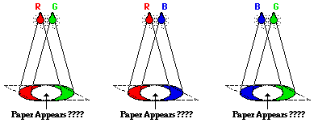

2. If magenta light and yellow light are added together, what color light is produced? Explain.

3. Blue jeans appear blue because the jeans are permeated by a chemical dye. Explain the role of the dye. That is, what does the dye do (absorb or reflect) to the various frequencies of white light?

4. A red shirt looks red when white light (R, G, B) shines upon it. Use your physics understanding to explain why the shirt looks red. (what is absorbed, what is reflected, etc)

5. Express your understanding of the rules of color subtraction by completing the following three diagrams. White light (red-green-blue) is aimed on a sheet of paper which is painted with a pigment which absorbs one of the primary colors of light. For each diagram, determine the color of the two reflected rays and determine the color which the paper appears.

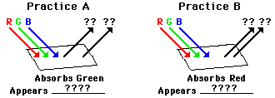

Color Subtraction Part I

1. Two lights are arranged above a white sheet of paper. When the lights are turned on they illuminate the entire sheet of paper (as seen in the diagram below). Each light bulb emits a primary color of light - red (R), green (G), and blue (B). Depending on which primary color of light is used, the paper will appear a different color. Express your understanding of color addition by determining the color which the sheet of paper will appear in the diagrams below.



2. If magenta light and yellow light are added together, what color light is produced? Explain.

3. Blue jeans appear blue because the jeans are permeated by a chemical dye. Explain the role of the dye. That is, what does the dye do (absorb or reflect) to the various frequencies of white light?

4. A red shirt looks red when white light (R, G, B) shines upon it. Use your physics understanding to explain why the shirt looks red. (what is absorbed, what is reflected, etc)

5. Express your understanding of the rules of color subtraction by completing the following three diagrams. White light (red-green-blue) is aimed on a sheet of paper which is painted with a pigment which absorbs one of the primary colors of light. For each diagram, determine the color of the two reflected rays and determine the color which the paper appears.

